KUBERNETES NETWORKING FUNDAMENTALS

NETWORKING FLOW
Cluster ------> worker node ------> pods ------> container --------> application
Application runs on a specific port inside the Container
↓
Container Port is exposed through the Pod
↓
Pod gets its own IP Address inside the Cluster
↓
Service exposes the Pod IP and Port
↓
NodePort/LoadBalancer exposes the Service outside the Cluster
↓
User accesses the Application using:
NodeIP:NodePort
or
LoadBalancer DNS/IP

SERVICES in KUBERNETES
A Kubernetes Service is used to expose Pods outside of the cluster and provide stable networking.
Types Of Services In Kubernetes
- ClusterIP
- NodePort
- LoadBalancer

1. ClusterIP (Default)
- Exposes application only inside the cluster
- Cannot access from outside
- Provides a stable/static virtual IP address for communication
- Used for internal communication between Pods and Services
- And it’s a Default service type in Kubernetes

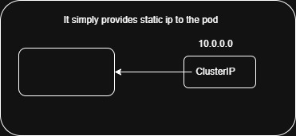

- kubectl run cipod --image=nginx --port=80
- kubectl expose pod cipod --name=cipod-svc --type=ClusterIP --target-port=80 --port=80
- kubectl get pods -o wide
curl <ip_pod>
- kubectl get svc -o wide
- kubectl delete pod cipod

2. NodePort
- Exposes application outside the Kubernetes Cluster
- Application can be accessed using NodeIP:NodePort
- Its range started from 30000–32767

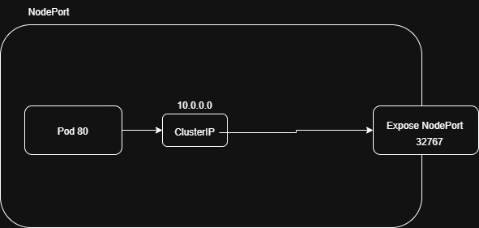

- kubectl run nppod –image=nginx –port=80
- kubectl expose pod nppod --name=nppod-np --type=NodePort --target-port=80 --port=80
- kubectl get svc -o wide
- kubectl get nodes -o wide
curl <node_ip:expose_port>
- kubectl delete pod nppod

3. LoadBalancer
- Exposes application using an external cloud Load Balancer (DNS)
- Automatically distributes traffic across Pods

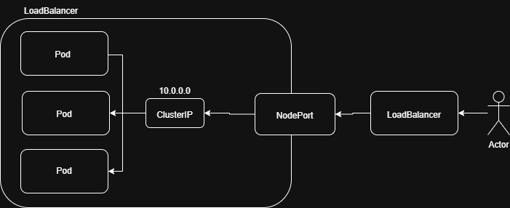

- kubectl run lbpod –image=nginx –port=80
- kubectl expose pod lbpod --name=lbpod-lb --type=LoadBalancer --port=80 --target-port=80
- kubectl get nodes -o wide
- kubectl get svc -o wide
<dns_name> ----> hit on web
- kubectl delete pod lbpod

COMMANDS
- kubectl get svc -o wide
- kubectl describe pod <pod_name>

DIFFERNCE BETWEEN INTRA-POD & INTER-POD COMMUNICATION

INTRA-POD
- Communication happens between containers inside the same Pod.
- All containers share the same IP address and network namespace.
- Containers communicate using localhost.
- Mainly used for sidecar and helper container communication.

INTER-POD
- Communication happens between different Pods in the cluster.
- Each Pod has its own unique IP address.
- Pods communicate using Pod IP or Kubernetes Services.
- Mainly used for communication between microservices applications.

